Cloud Offerings: Types, Examples
cloud offering simply refers to any service that a cloud provider delivers over the internet, instead of you managing it on your own hardware.
Think of it as renting computing resources, storage, software, or tools from a provider like Microsoft Azure, AWS, or Google Cloud — you only pay for what you use.
A cloud offering is a service or resource provided by a cloud service provider (like AWS, Azure, or Google Cloud) over the internet.

Why Cloud Offerings Exist
Traditional IT:
- Buy servers 🖥️
- Install software
- Maintain data centers
- High cost & slow setup
Cloud:
- Use ready-made services
- No hardware management
- Fast, scalable, cost-effective

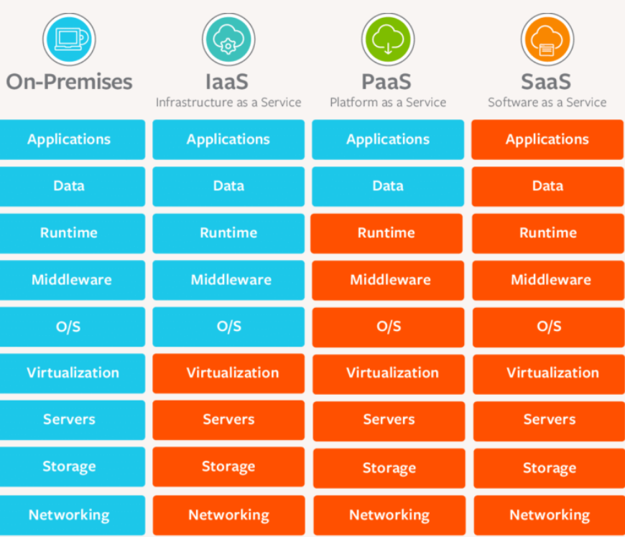

Main Types of Cloud Offerings
IaaS is a cloud service model where a cloud provider gives you basic IT infrastructure over the internet.
👉 You get virtual machines, storage, and networking
👉 You manage the OS and applications
👉 The cloud provider manages the physical hardware
IaaS = Renting IT infrastructure instead of buying servers

When to Use IaaS (Infrastructure as a Service) ☁️
Use IaaS when you need maximum control over your infrastructure but don’t want to manage physical hardware.

Infrastructure as a Service (IaaS)
💡 Basic building blocks of IT
What you get:
- Virtual servers
- Storage
- Networking
Examples:
- AWS EC2 (Virtual Server)
- AWS S3 (Storage)
- Azure Virtual Machines
Use case:
“I want full control over servers but don’t want to buy hardware.”

Real-Life Example
Instead of buying a house, you rent an empty house:
- You decide furniture (OS, apps)
- Owner manages building & electricity (hardware)

PaaS — Platform as a Service
You get a platform to build, run, and deploy applications without managing servers.
- Example: Azure App Service, Google App Engine
➡️ Great for developers — you focus on coding, cloud handles everything else.
Platform to build and deploy applications
What you get:
- OS
- Runtime (Java, Python, etc.)
- Database
- App hosting environment

Examples:
- AWS Elastic Beanstalk
- Azure App Service
- Google App Engine
Use case:
“I just want to deploy my code, not manage servers.”

Real-Life Example
Think of PaaS like a ready-made kitchen:
- You cook food (write code)
- Kitchen tools & maintenance are handled for you

SaaS — Software as a Service
You get ready-to-use software via the internet.
- Example: Microsoft 365, Gmail, Salesforce
Ready-to-use software over the internet
What you get:
Complete applications
Access via browser
Examples:
Gmail
Google Drive
Salesforce
Use case:
“I want to use software without installing anything.”

Real-Life Example
SaaS = Hotel stay
- You just use the room
- Hotel manages cleaning, electricity, maintenance

FaaS / Serverless
You write small pieces of code (“functions”) and the cloud runs them automatically.
- Example: Azure Functions, AWS Lambda
➡️ Pay only when your code runs — very cost-effective

Deployment Models
- Public Cloud — Shared infrastructure (Azure, AWS).
- Private Cloud — Dedicated to one organization.
- Hybrid Cloud — Combination of both.
- Multi-Cloud — Using multiple cloud providers.

Benefits of Cloud Offerings
- No hardware management
- Pay-as-you-go pricing
- High scalability
- Global availability
- Built-in security features

